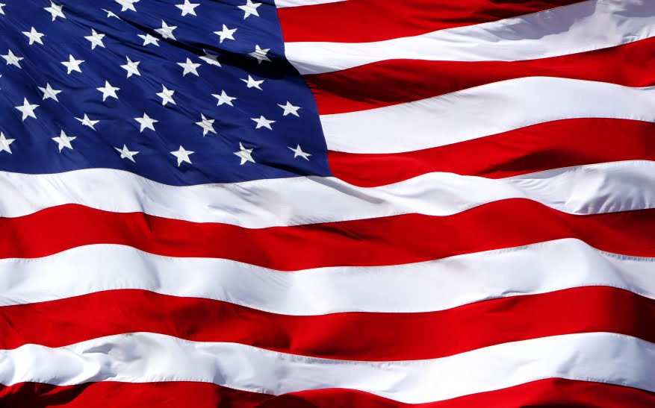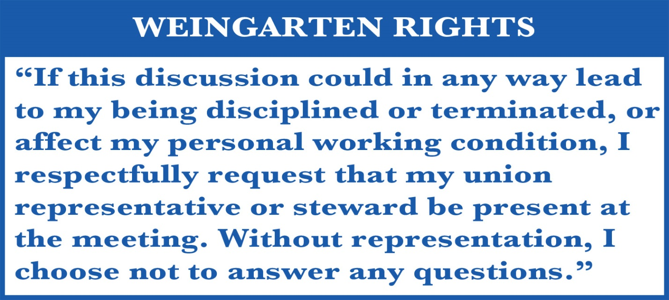 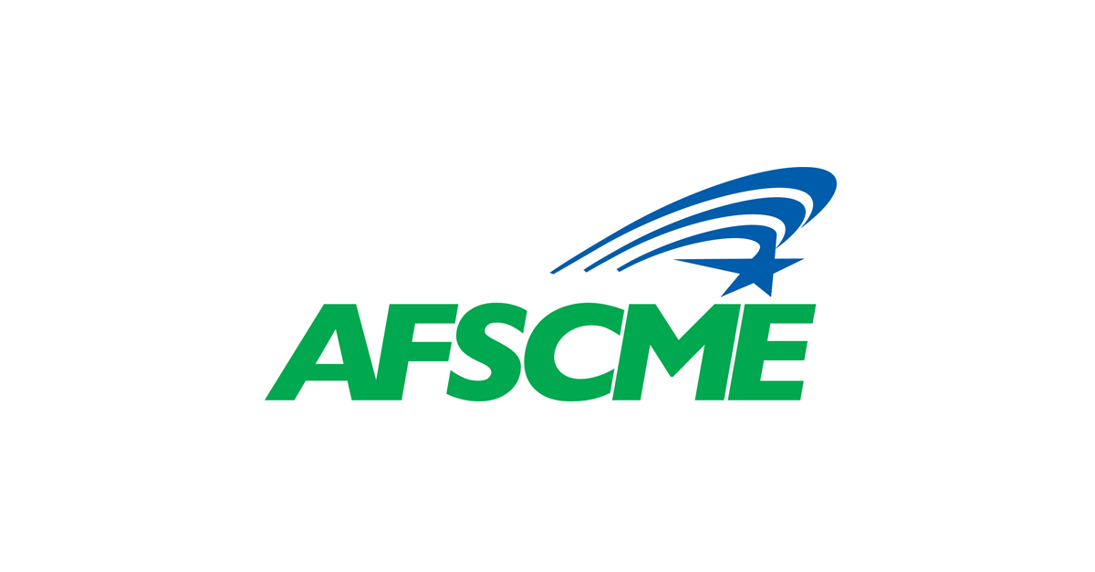 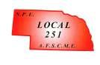

**YOU HAVE THE RIGHT TO UNION REPRESANTATION.**

NEBRASKA PUBLIC EMPLOYEES LOCAL 251

6910 PACIFIC ST. #450

OMAHA, NE 68106

(402) 346-4011

LOCAL251@LOCAL251.COXATWORK.COM

