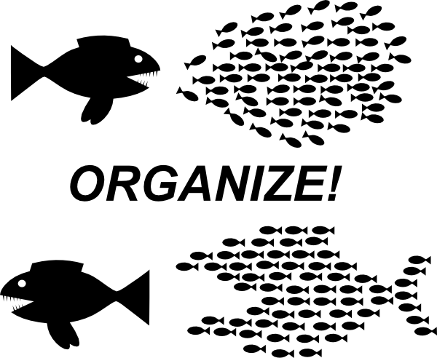

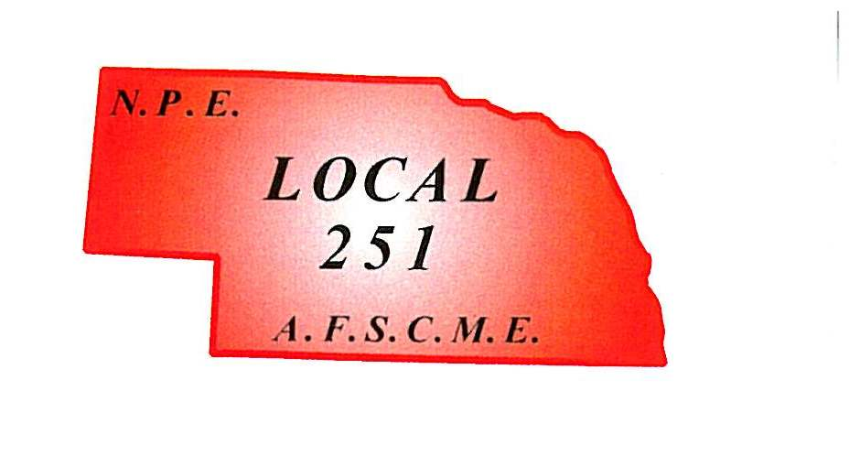

KNOW YOUR RIGHTS

Nebraska Public Employees

Local 251 Officers

Local 251 Ofiicers

Date of publication

WEINGARTEN RULING

If the discussion in this meeting could in any way lead to my being disciplined, terminated or have impact on my personal working conditions, I request that my steward, local union officer or union representative be present. Without union representation, I choose not to answer any further questions at this time.

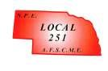

6910 Pacific St. #450

Omaha, NE 68106

Phone (402)346-4011

Nebraska Public Employees

Date of publication
A decision to join the American Federation of State, County and Municipal Employees, Local 251 is a wise choice. Under the auspices of this Union, you will be protected by a Collective Bargaining Agreement between Local 251 and the City of Omaha. The Union works for you the employee to give you a voice. The union makes it possible for you to stand up and let your voice be heard.
Tony Burkhalter, President
Kelcy Johnson, Vice President
Trent Wolford, Treasurer
Albert Davis, Secretary
Scott Dombeck, Board Member
Todd Morgan, Board Member
Terry Salem, Board Member
Scott Black, Board Member
Dick Rubek, Chief Steward
Michael Ellis, Steward
Fred Hartman, Steward
Scott Homan, Steward
Gary Jacobsen, Steward
Tony Kaiser, Steward
John Kilpatrick, Steward
Dave Kingrey, Steward
Nick McKenzie, Steward
Jim Miles, Steward
Will Schmidthuber, Steward
John Skow, Steward
Anthony Vidlak, Steward
Jeff Walker, Steward
Debra Williams, Steward,
Patrick Woods, Steward

WHY SHOULD YOU JOIN THE UNION?
Unions were formed so that they could have a say over their wages, hours, working conditions and the many other problems that arise in the relationship between a worker and employer. Union contracts provide far more protections for workers than state and federal laws. Most states follow a legal doctrine called “employment at will” and non-union workers can be fired for reasons that might be arbitrary or for no reason at all. Joining the Union helps to level the playing field between The City of Omaha and our employees.
Belonging to the Union gives you rights under the law that you do not have as an individual. The City of Omaha must bargain with the Union over your wages, benefits, hours and working conditions. These are things they cannot take away from us. Belonging to the Union gives you the opportunity for your voice to be heard and for you to stand up for what is best for you.

Our History
Nebraska Public Employees was chartered on May 26th, 1942 as the City of Omaha Employee’s Union, Local 251, American Federation of State County and Municipal Employees; and on the same date the Union was also chartered as the Nebraska Public Employees, Union Local 251 to represent all other municipal employees not covered by a Union charter.

WHAT YOU GET WITH YOUR UNION DUES
Nebraska Public Employees, Local 251 is a self-sustaining, not-for-profit organization that exists for the betterment of our members. Your union dues support…
- A Union Representative
- Contract Negotiations
- Expert Legal Counsel
- Monthly Rank And File Meetings
- Training and Education Opportunities
- Expert Consultants
- Grievance Procedure
- Scholarship Opportunities For You or Your Family
- Community Engagement
- And Much More!

Together we bargain Divided we beg
Company Name
Street Address
Address 2
City, ST ZIP Code
Phone (555)555-0125
Fax (555)555-0145
Web site address
Workers have less power when they act individually, but acting together as a group we can effect real change. Unions are the collective voice of workers. Unions are the workers watchdogs, using our power to ensure that workers’ rights under the law and collective bargaining agreement are protected.

Contact the Union office as soon as possible and join the union force to ensure your voice is heard and your rights as an employee are protected.
Current Union Dues: $50.00/ Month
Nebraska Public Employees
Tony Burkhalter, President
Kelcy Johnson, Vice President
6910 Pacific Street, Suite 450
Omaha, NE 68106
Phone: (402) 346-4011
Fax: (402) 346-6475
Email:
local251@local251.coxatwork.com

