## SKMBT_C35106090813380Image result for why should i join a union

**Tony Burkhalter**, President

**Kelcy Johnson**, Vice President

**Trent Wolford**, Treasurer

**Albert Davis**, Secretary

**Scott Dombeck**, Board Member

**Todd Morgan**, Board Member

**Terry Salem**, Board Member

**Scott Black**, Board Member

Dan Jourdan, Steward

John Perez, Steward

Alan Wallace, Steward



6910 Pacific Street, Suite 450

Omaha, NE 68106

**Phone**: (402) 346-4011  **Fax**: (402) 346-6475

**Website**: local251.org

**Email:**

local251@local251.coxatwork.com



A decision to join the American Federation of State, County and Municipal Employees, Local 251 is a wise choice. Under the auspices of this Union, you will be protected by a Collective Bargaining Agreement between Local 251 and the Douglas County Youth Center. The Union works for you the employee to give you a voice. The union makes it possible for you to stand up and let your voice be heard.

# ***Nebraska Public Employees***

Date of publication

***6910 Pacific St. #450***

***Omaha, NE 68106***

***Phone (402)346-4011***

***Local251.org***

**WEINGARTEN RULING**

If the discussion in this meeting could in any way lead to my being disciplined, terminated or have impact on my personal working conditions, I request that my steward, local union officer or union representative be present. Without union representation, I choose not to answer any further questions at this time.



## KNOW YOUR RIGHTS

# ***Nebraska Public Employees***

## Local 251 Officers

# ***Local 251 Ofiicers***

Date of publication

TOGETHER WE BARGAIN DIVIDED WE BEG

Workers have less power when they act individually, but acting together as a group we can effect real change. Unions are the collective voice of workers. Unions are the workers watchdogs, using our power to ensure that workers’ rights under the law and collective bargaining agreement are protected.

Contact the Union office as soon as possible and join the union force to ensure your voice is heard and your rights as an employee are protected.

Current Union Dues: $50.00/ Month

## WHAT YOU GET WITH YOUR UNION DUES

Nebraska Public Employees, Local 251 is a self-sustaining, not-for-profit organization that exists for the betterment of our members. Your union dues support…

* A Union Representative
* Contract Negotiations
* Expert Legal Counsel
* Monthly Rank And File Meetings
* Training and Education Opportunities
* Expert Consultants
* Grievance Procedure
* Scholarship Opportunities For You or Your Family
* Community Engagement
* And Much More!

WHY SHOULD YOU JOIN

THE UNION?

Unions were formed so that they could have a say over their wages, hours, working conditions and the many other problems that arise in the relationship between a worker and employer. Union contracts provide far more protections for workers than state and federal laws. Most states follow a legal doctrine called “employment at will” and non-union workers can be fired for reasons that might be arbitrary or for no reason at all. Joining the Union helps to level the playing field between Douglas County Youth Center and our employees.

Belonging to the Union gives you rights under the law that you do not have as an individual. Douglas County Youth Center must bargain with the Union over your wages, benefits, hours and working conditions. These are things they cannot take away from us. Belonging to the Union gives you the opportunity for your voice to be heard and for you to stand up for what is best for you.

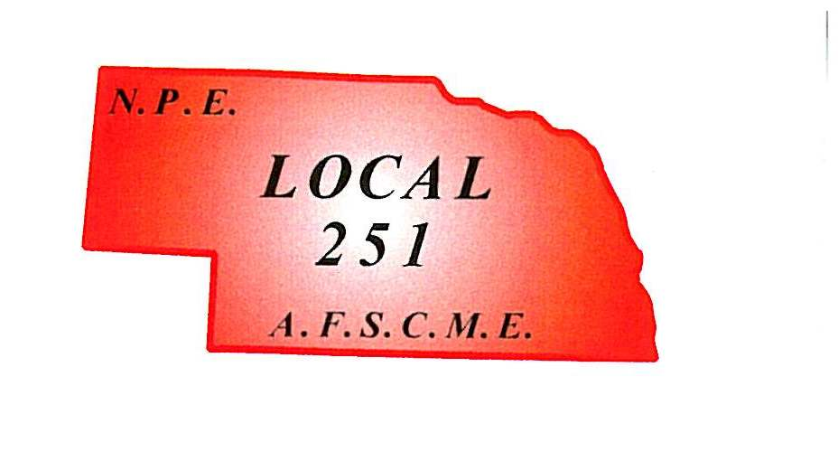

***Nebraska Public Employees***

**Tony Burkhalter**, President

**Kelcy Johnson**, Vice President

6910 Pacific Street, Suite 450

Omaha, NE 68106

**Phone**: (402) 346-4011  **Fax**: (402) 346-6475

**Website**: local251.org

**Email:**

local251@local251.coxatwork.com



## Our History

Nebraska Public Employees was chartered on May 26th, 1942 as the City of Omaha Employee’s Union, Local 251, American Federation of State County and Municipal Employees; and on the same date the Union was also chartered as the Nebraska Public Employees, Union Local 251 to represent all other municipal employees not covered by a Union charter.